PARISH NEWS
The Deverills & Crockerton

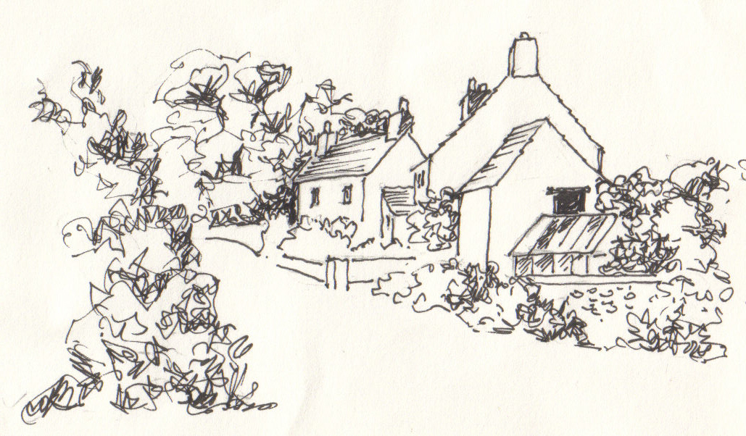

Monkton Deverill
by Pat Armstrong

May 2009

Look inside for local information
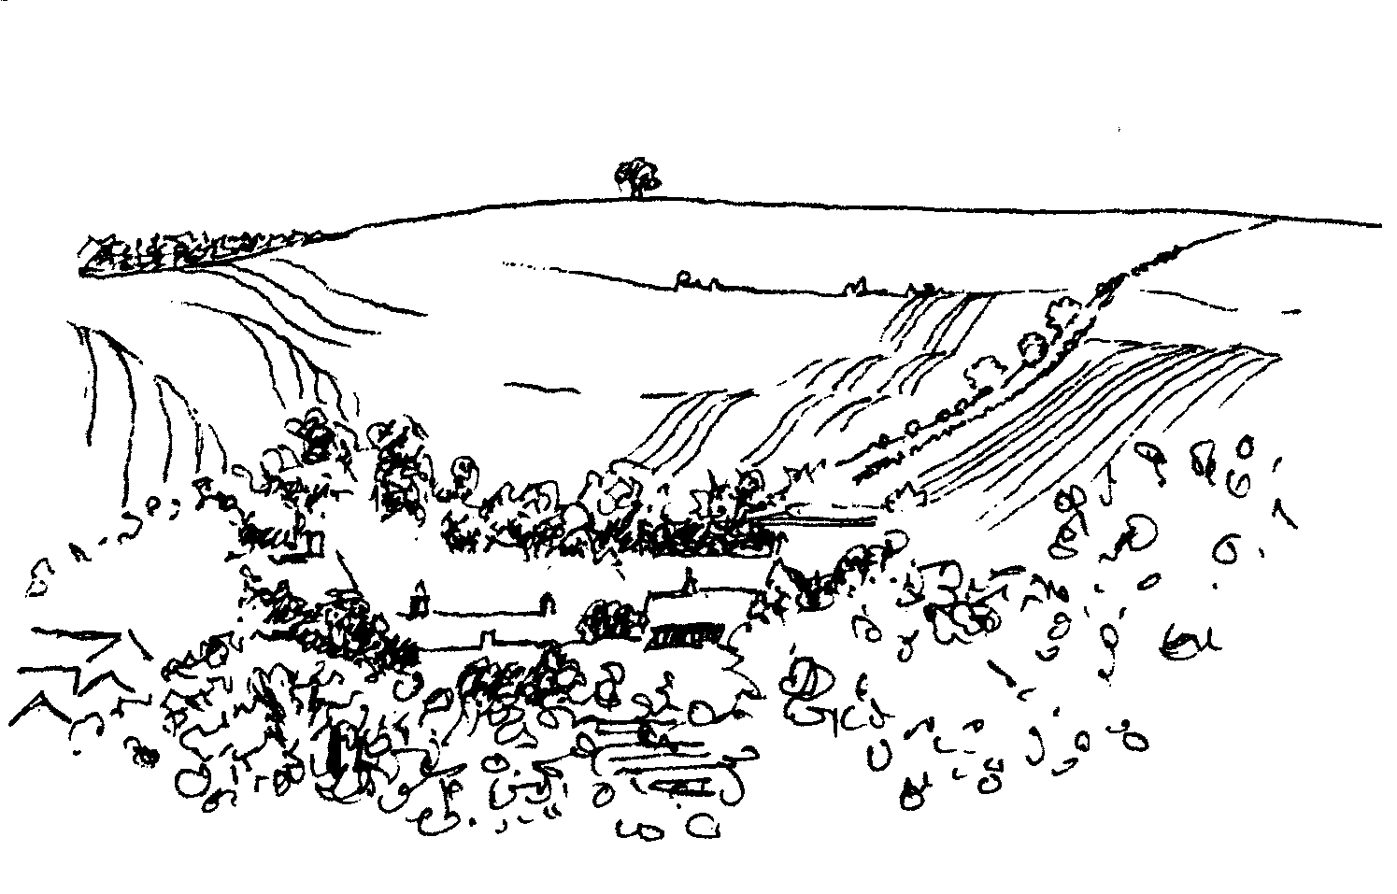
-2-

A Spring Time Concert
Love is in the Air! with The Phoenix Consort
St John’s Church, Horningsham
Saturday 16th May at 7.30 pm
Voices and instrumental music celebrating love in all its forms
From the Renaissance to the present day
Tickets £7.00 each available from:
Horningsham Post Office & Stores 844309 or John Webb 01373 836963
In aid of Wiltshire Air Ambulance

STICKY-TICKLES
Craft & Rhyme-time for under 5's
Longbridge Deverill Village Hall
Mondays 10.00 -11.30 am
From 20th April - 18th May (5 sessions) £5 a session
Please contact: Sarah 07968778631 (phone or text)

CROCKERTON VILLAGE COMMITTEE
Table Top Sale - Saturday 9th May
in The Bath Arms Car Park
Sellers £5 per table – set up from 9.00 am
Buyers 10.00 am - 12.00 noon
To book please contact:
Marion – 213739,Tracey – 216939, Bernie – 218401

Coffee, Cards and Chat
Come and enjoy looking at the new range of cards,
ribbons, wrapping paper, and other exciting items
displayed by John and Maddie Goodden
in the Upper Deverills Village Hall on Thursday 19th February
between 10.30 and 12.00 noon - everyone is welcome
Donations will be made to the hall and the church

Salisbury Theatre Club Trips
Monday 18th May
The Importance of Being Earnest by Oscar Wilde
The cost is £17.00: theatre seat £12.00 and coach trip £5.00
Booking and payment in advance to Mary Stewart Cox Tel 840877
Longmead, Brixton Deverill, Warminster BA12 7EJ
Coach leaves Kingston Church 6.10 pm collects through the Deverills
Performances begin at 7.30 pm

-3-

From your Rector
How worrying it has been in recent weeks to hear of so many examples of ill-judged actions! Whether in government or previously well respected institutions, news of leaks and misrepresentation, cavalier attitudes and disregard for others makes me feel very uncomfortable. Why is it that modern attitudes display such arrogance and so little respect?
For some time, there has been much talk of getting back to basics. An admirable aim, but one that is very difficult to achieve. The development of our legal system and mode of government have their roots in biblical principles. Talk of getting back to those principles is all very well, but society doesn’t allow that to happen easily. It is the ‘going back’ that is the problem. Modern society is always on the go. People often seem to be busier than ever. When we are absent from family or work for legitimate reasons, e.g. being on holiday or in hospital, the people and place to which we return are not the same as those we left. While we are absent, other people’s lives move on. They are not static; they do not remain the same, as though held in limbo awaiting our return. So searching to get back to things of the past, however worthy, may not be the best use of our energy.
It may be more productive for us to think of a journey of rediscovery, a moving forward to find again those values that create respect and honour in our society. Journeys invite us to travel onwards; even if we retrace our steps, we are moving forwards. Journeying may be routine, but is often exciting, opening new vistas and giving rise to novel situations. We cannot live in the past, or indeed see the past through rose-tinted spectacles. We must be realistic in our assessments and realise that if we wish things to change, that journey starts with us.
The Church continues through the month of May to mark the season of Easter, during which we celebrate the new life we are offered through the death and resurrection of Jesus Christ. Easter reveals the depth of God’s love for the world. Knowing God’s love means that we can learn to know and love ourselves for who we are, and not through our achievements. When we love and respect ourselves, we will value and respect others. Then there is hope that this will spill over into all walks of life, among the young, the old, the employed, the unemployed, the anxious and the dispossessed, the active and the dependent, among people of faith or of none.
May God bless your journeys of rediscovery!
Norma Payne
Annual Parochial Church Meeting
Thank you to everyone who attended the meeting on 19th April, and to all those who contribute so generously with their time in so many ways to the running of our churches in the Parish. It was good to have a time of fellowship after the meeting while enjoying delicious eats and drinks.

-4-

Christian Aid week 10th to 16th May
Lunch at the Rectory to support Christian Aid on Friday 15th May,
12.00 noon - 2.00 pm, soup and a roll, come along and enjoy some fellowship.
As agreed at the Annual Parochial Church Meeting it has been decided to organise our Christian Aid collection differently this year. Instead of a door to door collection we will be distributing an envelope with each Parish News. We hope you will feel able to give generously to this wonderful charity which helps some of the poorest and most disadvantaged people in the world. Particular emphasis this year will focus on the Democratic Republic of Congo where conditions for people are particularly harsh. Envelopes can be brought to church services on 17th May or taken to a ‘collection’ house, by 16th May, in each village as follows:
Crockerton: Gill Carlile, The Corner House, 37 Dry Hill.
Longbridge: Norma Payne, 6 Homefields.
Brixton: Mary Stewart Cox, Longmead.
Monkton: Mike Tulloch, Spring Cottage.
Kingston: Judy Munro, Whitepits Lodge.
Please complete the gift aid section if you are able to and ensure the envelopes are handed in during the collection week to enable us send our contribution to the charity quickly. Thank you. For any queries please contact me.
Judy Munro 844385
Save the Children Fund
Cream teas and open garden in aid of Save the Children will be held at Mill Farm House, Hill Deverill on Sunday 31st May between 3.00 – 6.00 pm and on the last Sunday of the following months, 28th June, 26th July, 30th August, and 27th September. Do come and join us for an enjoyable and relaxing afternoon.
Anne Hurd
2009 Wylye Valley Calendar
Many thanks to everyone who supported Hope and Homes for Children by purchasing a copy of the 2009 Wylye Valley Calendar. The sale of calendars raised a total of £4,587 for the charity. Based in the Wylye Valley, Hope and Homes for Children is an international children’s charity working across Africa and Central and Eastern Europe to transform the lives of children who are orphaned, abandoned or vulnerable (registered charity no. 1089490).
Chris Lock
The Deverills Cricket Club
The new season will start on 26th April with an away match at Steeple Langford. Home matches take place on the cricket ground next to the Upper Deverills village hall, please do come along to watch and support us. Home fixtures are on:
17th May, 14th & 28th June, 5th & 26th July,
16th, 23rd & 31st August, 6th & 13th September
If you would like to join the club and require further information please call Pete Child on 01963 34593 or Jamie Fagan on 01985 844123 / 07796 698180.

-5-

Deverill Valley & Crockerton Women's Institute
The Deverill Valley and Crockerton WI members are delighted that Hindon WI’s concern about the decline of honeybees is on the agenda at the Annual General Meeting of the WI in London this year. We will talk about this at our meeting on Monday 11th May, when we will also be shown the new buildings at Denman, which is our unique college, also open to non members.
On Thursday 14th May a Group meeting will take place at 7.30 pm in Sutton Veny hall. You may wonder what a WI Group meeting is. It is usually held twice a year when a number of local WIs come together. In this case Mere, Warminster, Boreham, Sutton Veny, including the new 'Lite' WI, and the Deverill Valley will combine for a friendly get together. John Ericson, an accomplished speaker, is talking on 'Norman Rockwell, illustrator or great artist?' Group meetings are not part of the WI constitution and are open to non members - see you there?
Jill Russell 840209
Upper Deverills Village Hall
Committee Annual General Meeting 7.30 pm Wednesday 20th May
The AGM will take place in the village hall where everyone is welcome to attend and offer their views and suggestions regarding the role of the hall together with the nature and frequency of events. New Committee members are always welcome. Unfortunately the Curry Supper scheduled for Saturday 19th April had to be postponed until later in the year due to insufficient sale of tickets.
Annual Rounders Evening Friday 19th June
The traditional rounders evening will take place on the cricket pitch adjacent to the village hall starting at 6.00 pm. This is an evening not to be missed, sporting skills are not necessary to take part. Bring the whole family to what is one of the most enjoyable village hall events.
Forthcoming events
Duck Race 6.00 pm Saturday 4th July, Annual Fete 2.00 pm Saturday 18th July
Longbridge Deverill Village Hall
The committee’s thanks to Guy Hagg for an enlightened illustrated talk on swimming with sharks, a very pleasant evening and delicious ploughman’s supper.
Thank you to Jo Nelson and other members of the hall committee who resigned at the AGM after many years of hard work. Under Jo’s leadership many improvements have been made at the hall and many very enjoyable events have taken place. Welcome to Julie Read in her new role as Chair. If anyone would like to join the committee please get in touch with her on 840655. We would like to hear what sort of entertainment you would like to see at the hall to keep it open for use by the villagers and raise money for its maintenance.
Forthcoming events
July - Quiz Night, September - Harvest Supper
October - John’s Local Talent Music Night, December - Carol singing
(May/June - Open Gardens has been cancelled)

-6-

Fifth Wylye Valley Art Trail Saturday 30th May - Sunday 7th June
This biennial festival of open studios, workshops and exhibitions, is within a 12 mile radius of the centre of the Wylye Valley, south Wiltshire, covering Hindon, Tisbury, Mere, Warminster, Westbury and villages in between. Since the first event in 2001, the Art Trail has developed into the largest visual arts event in Wiltshire, attracting many local artists, craftspeople and groups and bringing in large numbers of visitors. The artists taking part range from regionally and nationally acclaimed figures, those beginning to make names for themselves locally and some discovering their talents as students or members of groups. Each have a unique vision, a particular way of making art, contributing to the exciting cultural profile of this part of the county. Events taking place in The Deverills and Crockerton are as follows:
Event 32: Exhibition of paintings by Pat Armstrong and the 'Look and See' group at Kingston Deverill Village Hall open 10.30 am to 5.00 pm, except Thursday 4th June
Event 33: Batik (wax resist and dye on fabric) paintings of wildlife and nature by Mandy Martyn at The Garage Gallery, 67 Kingston Deverill.
Event 34: Contemporary paintings, prints, photography, jewellery, furniture, sculpture at The Barn, Manor Farm, Monkton Deverill. Artists: Sandy Crole, Margaret Turner, Johnny Bull, Gerry Baptist, Rupert Bevan, Tim Harrisson, Thom Bridle.
Event 35: Exhibition of contemporary woodwork and photography by Antaro Ofer Margolin – all inspired by this beautiful valley. Also a collection of vibrant mixed media paintings by Angie Margolin at 2 Whitecliff Farm Cottages, Brixton Deverill.
Event 36: Studio 90 at Mill Farmhouse, Hill Deverill: paintings covering a wide range of subjects by Mike Allardice, Julia Haes, Amanda Harris, Sandrine Maubeche, Jo Miln, Mark Muspratt-Williams, Jane Parsons.
Event 37: Panoramic photography and video art by Jean-Paul Sant. Screenprints, collographs and monoprints by Maggie Sant. Also abstract paintings by Tony Sant at ‘Riverside’, Sand Street, Longbridge Deverill.
Event 38: Exhibition at Lakeside Garden Centre, Crockerton: paintings from still-lives and interiors to skyscapes and other curiosities by Jules Horn. Also cyanotypes of flowers and papographs by Jennie Gilling in which handmade paper is merged with photographic details.
Event 39: Artists and craftspeople living and working at Bull Mill are opening their studios and workshops to show a wide range of contemporary art, including painting, sculpture, jewellery, printmaking, photography, gilding and textiles. Nick Andrew, Kate Andrew, Sally Alexander, Olivia Clifton-Bligh, Daniel Petkoff, Dean Brodrick, Stephanie Gilbert, Joanna Sims and Philip Leevers.
Event 40: Woodturning by Trevor Parry, turned and sculpted from a wide selection of native and exotic woods at the Wylye Valley Vineyard, Sutton End, Crockerton.
Event 41: Exhibition at Wylye Hall studios (formerly Holy Trinity Church), Potters Hill, Crockerton, of digital printmaking and mixed media by Jane Humphrey, mixed media paintings and prints by Sue Conrad and delicate and detailed pencil drawings by Kim Underwood.
Images and more details in the guide map, available at Longbridge Deverill Garage, The Bath Arms and Lakeside Garden Centre or go to www.wvat.co.uk

-7-
Plant Sale and Wylye Valley Art Trail
Manor Farm in Monkton Deverill will be holding a plant sale on Saturday 30th and Sunday 31st May, from 11.00 am to 6.00 pm. We are selling beautiful and difficult to find hardy perennials, annuals and vegetables. Our barn will also be open to view artists participating in the Wylye Valley Art Trail including watercolour and ink paintings by Sandy Crole of churches along the Wylye Valley.
Charlotte & James Williams 844900
The Old Pottery at Bull Mill, Crockerton
On Saturday 2nd May:
Open Studios: visitors welcome 10.00 am-4.00 pm, & by appointment
Children's Art Club: 10.30 am-12.30 pm (ages 6 upwards) £7.00
Tango Classes: 4.00 pm-7.00 pm £10.00, beginners welcome!
Yoga: classes in Crockerton on Tuesday & Thursday evenings,
Wednesday mornings. Beginners welcome!
For all details, please call Olivia and Daniel 212716

The George Inn - Pumpkin, Beer and Cider Festival
The George Inn at Longbridge Deverill is launching its first ever Pumpkin Festival at the pub on the weekend of 2nd - 4th October. The event will incorporate a beer and cider festival with live music and entertainment, but its centrepiece will be the grand Pumpkin Competition, which will be open to keen gardeners, novices and Pumpkineers of all ages! To help you get growing, the George will be selling packs of pumpkin seeds for £2.00 each with all profits going to the charity Help for Heroes. There will be three varieties of seeds on sale:
The Atlantic Giant - suitable for the more serious Pumpkinologist, and holder of the present world record at 1,528 lb (please remember you are responsible for the transportation of your Pumpkin!)
The European Mammoth - which grows to between 10-15 kg and is suitable for people with all levels of knowledge of Pumpkinology.
The Jack O’Lantern - which is the perfect carving pumpkin.
The competition will see the Atlantic Giants and European Mammoths being judged on weight, while the Jack O’Lanterns category will have a prize for the best carved pumpkin (with child and adult categories). There will also be a prize for the most unusual use for a pumpkin! We are really excited about launching the Pumpkin Festival and keen to encourage people to start growing with our charity pumpkin seeds. This will give people who are interested in entering our pumpkin competition an opportunity to buy seeds which are easy to care for. Growing vegetables is a fun activity for children and adults alike, particularly in the current economic climate, and it’s all in a good cause! For optimum planting potential you need to have planted the seeds between April and June, the earlier the better if you want to grown a monster! For further information, please contact Laurie Creighton (professor of Pumpkinology!) manager of the George Inn on 840396.

-8-

SERVICES PARISH OF DEVERILLS & HORNINGSHAM
Sunday Easter 4
3rd May Brixton 8.00 am Holy Communion 1662
Longbridge 10.30 am Morning Worship
Sunday Easter 5
10th May Kingston 10.30 am Holy Communion
Horningsham 11.15 am Holy Communion
Sunday Easter 6
17th May Longbridge 8.00 am Holy Communion 1662
Brixton 10.30 am Holy Communion
Horningsham 6.30 pm Rogation
Thursday Ascension Day
21st May Longbridge 6.30 pm Evening service
Sunday Easter 7
24th May Longbridge 10.30 am Holy Communion
Horningsham 11.15 am Morning Prayer
Kingston 6.00 pm Evening Prayer
Sunday Pentecost
31st May Horningsham 10.30 am Benefice Service
Sunday Trinity
7th June Kingston 8.00 am Holy Communion 1662
Longbridge 10.30 am Morning Worship
Horningsham 6.30 pm Evensong

Tuesday Wednesday Thursday Friday Longbridge 8.30 am Prayers
Wednesday Longbridge 10.15 am Holy Communion
Bell Ringing at Longbridge Deverill Church
Thank you to everyone who came along to the ‘taster’ evening on 22nd April, and to those who expressed an interest but were unable to come on this occasion. We welcomed the instruction from Stephen Young and everyone enjoyed getting to know the ropes! Future practice sessions will take place every Wednesday evening 7.30 - 9.00 pm. Come and join us.
Richard Munro 844385
The New Deverill Choir
Come and Sing! No experience necessary. Everyone welcome. Friday 8th May 7.30 - 9.00 pm, Longbridge Deverill Village Hall. For more information contact Claire Johnson 840787 or just come along.

-9-
Ivy House St Denys Retreat Centre
Thursday 7th May - CSD Gathering Day
‘A quiet day of guided reflection open to all’
Thursday 21st May - Quiet Garden Day
A place for rest, refreshment and renewal
Cost: £16.00 including coffee, lunch and tea
To book and for more information please phone 214824
Contact the Clergy
Please contact Norma Payne (841321) or Di Britten (01373 832515) if anyone is housebound and would like communion or a visit at home; or if someone is ill and needs our prayers; or to discuss any church matter.
Office administrator phone 210149 or email: office@cleyhill-team.org.uk

SERVICES PARISH OF CORSLEY & CHAPMANSLADE
Sunday Easter 4
3rd May Chapmanslade 9.00 am Patronal Festival

Sunday Easter 5
10th May Chapmanslade 9.00 am Holy Communion
Temple 11.00 am Morning Prayer

Sunday Easter 6
17th May Corsley 10.30 am Parish Rogation Service
(High House Farm)
Thursday Ascension Day
21st May Corsley 11.00 am Morning Service
(soup & cheese lunch)
Sunday Easter 7
24th May Temple 9.00 am Holy Communion 1662
Corsley 10.30 am Parish Service

Sunday Pentecost
31st May Horningsham 10.30 am Benefice Service

Sunday Trinity
7th June Corsley 9.00 am Holy Communion

-10-

Longbridge Deverill and Crockerton Parish Council
Dog Wardens doing rounds in Crockerton
At least six stray dogs in Crockerton have been reported to the dog warden. Could dog owners please check their fences to ensure that their dogs are not wandering onto roads risking an accident. Dog Wardens are empowered to impound any stray dogs and then owners will have to pay to collect them.
Parish Council’s next meeting 7.30 pm Tuesday 5th May, Longbridge Hall
Upper Deverills Parish Council
Annual Parish Meeting 7.00 pm Wednesday 6th May
Upper Deverills Hall, followed by the Annual Council Meeting. All are welcome.
Wiltshire Council
With Wiltshire Council forming on 1st April, Michael Mounde is no longer our District Councillor; all such posts in Wiltshire have been abolished. Fleur de Rhé Philipe, as the existing County Councillor, takes on all the local councillor responsibilities until the local elections on Thursday 4th June. Fleur and Michael will be standing for the new county divisions, along with other candidates, at the elections. For more information see www.wiltshire.gov.uk

Church Cleaners for May
Kingston - Mrs Fagan & Mrs Munro
Brixton – Mrs Greenwood & Mrs Marsh
Longbridge - Monday 11th May -9.30 - 10.30 am - all helpers
Church Flower Arrangers for May
 | Kingston | Brixton | Longbridge
3rd May | Mrs Royal | Mrs Marsh | Miss Renshaw
10th May | Mrs Askew | Mrs Marsh | Mrs Atkinson
17th May | Mrs Askew | Mrs Burridge | Mrs Atkinson
24th May | Mrs Stratton | Mrs Burridge | Mrs Budgen
31st May | Mrs Stratton | Lady Walker | Mrs Budgen

CONTACT THE EDITOR AND WEBSITE
Parish News Editor - Judy Munro 844385
Contributions for the Parish News through my letterbox or
by post to Whitepits Lodge, Kingston Deverill, Warminster,
BA12 7HD or by Email: judymunro@tiscali.co.uk Thank you
Please remember the deadline is the 15th of every month

Website: www.deverills.org.uk Email address:info@deverills.org.uk
Website manager : Kate Wilkinson 844998
Contents: Parish News with church services, Parish Register, Events, Local News plus pictures and other information
-11-

Nature Notes
It’s always a thrill to see your first swallow of the year. I saw mine on the 29th March, just a glimpse of one out of the kitchen window, but then later when we went over to Stourhead for an evening walk, we saw several feeding low over the lake. Just over a week later on the 8th April I heard a cuckoo for the first time calling very loud and clear, in the still of the evening, in the woods at the top of the farm just above Shearwater. I am sure that it is the earliest that I’ve ever heard one. I heard my first blackcap on the 3rd April singing very loudly in the copse on the hill opposite the farm, and yesterday there was one singing in the garden whilst we planted the seed potatoes.
I am now looking out for ‘our’ house martins to return. When they do I think that they may find squatters in their nests as I’ve seen and heard tree sparrows around at least two. All the birds are singing well now and will continue to do so for the next month with the dawn chorus reaching a climax about mid May. All birds sing well first thing in the morning to announce to other birds in the vicinity that they have made it through the night and that this is their patch. They will sing at other times during the day but the intensity of sound in the morning is for this reason.
The hares continue to entertain in the fields with their interactions. We saw a good bout of boxing back at the beginning of the month, on 3rd April, lasting a good half a minute and the same evening we heard the curlew calling. The badgers in the lane have been very busy shifting earth about doing some ‘house cleaning’. The cubs will be coming out of the sett for the first time very soon having been born in late January/February.
We held a walk here on the farm for the Bath Natural History Society last Saturday and with 16 pairs of ears and eyes a pied flycatcher was spotted at the top of the farm and a marsh tit on the banks of Shearwater. The flycatcher was probably en route for an old Welsh woodland. Last year I was lucky enough to see a redstart on the farm no doubt also heading for a similar wood. We have another walk this coming Saturday for the Salisbury RSPB group so I will report next time on anything exciting that turns up.
On that note, I have had several sightings passed on to me. A red poll has been feeding in the village and grey partridges have been spotted in the area. A great bustard has ‘escaped’ from Salisbury plain and is in the Wylye valley apparently spending time with some mute swans. Also a group of 5 or 6 buzzards were seen fighting on the edge of the village possibly due to their numbers increasing and population pressure. Just to think 20 years ago you hardly ever saw a buzzard around here.
Jane Trollope (written on 14th April)

-12-

Where have you been?
The Café at the Cheese and Grain Hall, Frome
We are very keen on Farmers’ Markets and the opportunity to buy local produce so we often go to the Cheese and Grain Hall in Frome on the second Saturday of the month to visit the Farmers’ Market there. About a month ago we decided to have lunch at the café in the corner of the hall as it always seems to be very popular. We both opted for the all day breakfast; I had the bacon breakfast (£3.95) and my husband went for the Balmoral breakfast (£4.50). I have to say we were both well satisfied. The bacon breakfast consisted of two eggs, two rashers of bacon, beans and two slices of toast. The Balmoral had all of the above plus a sausage and tomato. We both thought it was excellent value for money. The proprietress is charming and fastidious about keeping tables clean etc, which gives one confidence in the cleanliness of her kitchen! She also runs an events catering business, so she knows what she’s about. Apart from the breakfasts described here you can also have things like scrambled eggs with smoked salmon, porridge with maple syrup (wisht ye Scots out there!), soup, baguettes, ham, eggs and chips and so on, all very reasonable priced. There is also a wide variety of drinks available. You may be interested to know that all tea and coffee is Fairtrade, so you can enjoy with a clear conscience. Opening times are from 8.00am to 2.00pm on Wednesdays, Thursdays and Saturdays. If you are in the area, I recommend you give it a try.
Forthcoming events… Shaftesbury Local Food Festival, 2nd and 3rd May
I just wanted to draw your attention to the Shaftesbury local food festival which takes place in the main streets of Shaftesbury on Saturday 2nd & Sunday 3rd of May. Events on Saturday include a special Farmers’ Market on Park Walk (the pedestrian way in front of the abbey with spectacular views), a local sausage competition in the High Street as well as May dancing. On Sunday there are food and craft stalls in Swans Yard, a barbeque in Bell Street from noon onwards and live jazz from 4 x 4 Jazz Band outside the Bell Street café and in Swans Yard throughout the day. There are also events leading up to the festival from 25th April. For details of these and the festival itself try to pick up a brochure (Pure Pigs near Mere has them as does Shaftesbury Tourist Information Centre and many other places), or, if you have access to the internet, look on www.swanhosting.co.uk/shaftesburylocalfoodfestival.
If you have somewhere you would like to recommend, please send your comments and suggestions to me by email at farthings.kd@btinternet.com or through my letter box at Farthings, Kingston Deverill. I am running out of inspiration, so I would be very grateful for your suggestions.
Trish Shuler

-13-

Victoria County History of Wiltshire
New Wylye Valley Volume
Are you interested in local history? Would you like to help with an exciting new project? The Victoria County History of Wiltshire has just begun researching its 19th volume, covering parishes in the Wylye Valley that are in the old Hundreds of Heytesbury and South Damerham. In 2007 the book ‘Codford Wool and War in Wiltshire’ was published, a project which involved both the VCH and volunteers. Volume 19 of the Wiltshire VCH also hopes to involve voluntary researchers. If you live in one of the Wylye parishes, or elsewhere, and would still like to be involved, come along to the Warminster History Society meeting on Monday 11th May at 7.30 pm in Warminster Library. The editor of the Wiltshire VCH, Dr. Virginia Bainbridge, will be giving a talk entitled ‘New Research on the Longleat Estate and the Upper Wylye Valley’. For more information please contact Helen Taylor on 01249 705500 (daytime) or email pottlepress@btinternet.com
Recipe of the Month - Moroccan Chicken
Serves 8 - from Liz Nixon
1 kg chicken breast cut into 4 cm pieces 1 tablespoon of sesame seeds
2 onions, peeled and sliced 1 teaspoon ground black pepper
4 cloves garlic, peeled and sliced 1 teaspoon salt (or to taste)
3 tablespoons olive oil 1 teaspoon ground cinnamon
3 tablespoons runny honey 2 teaspoons ground ginger
2 teaspoons lemon juice 1 teaspoon ground coriander
100 g of pitted dates 1 teaspoon ground cumin
100 g of dried apricots Pinch of Saffron
1 handful of sliced almonds
Method
1. In a large and deep pan or casserole gently fry the onion in the olive oil until soft. Add the chicken, ginger and coriander to the pan and cook until chicken is browned on all sides. Add garlic, salt, cumin, black pepper, cinnamon, saffron and water to cover chicken.
2. Simmer gently until chicken is cooked (approx. 45 minutes) and remove chicken from the pan with a slotted spoon and keep warm.
3. Add dried fruits (dates and apricots), honey and lemon juice to the liquid in the pan/pot. Simmer uncovered until fruit is soft and sauce is reduced and slightly thickened (approx. 15 minutes).
4. Return chicken to pan, mix thoroughly and heat through.
5. Roast sesame seeds/almonds under the grill.
6. Place chicken in serving dish and cover with roasted sesame/almonds.
7. Serve hot with couscous and a green salad.
This recipe is sponsored by Maiden Bradley Community Shop (844206); all the ingredients are available there to purchase. The Post office is open: mornings only.
Shop opens:
Monday, Tuesday, Thursday, Friday 8.00 am – 6.30 pm;
Wednesday 8.00 am – 6.00 pm
Saturday 8.00 am – 1.00 pm; Sunday 10.00 am – 12.00 noon

-14-

LOCAL COUNCILS, SOCIETIES, GROUPS etc.
Longbridge and Crockerton Parish Council
Karen Manfield 215526 (Chair) Peter Whithey 840347 (Vice Chair)
Helen Few 840119 (Clerk) Thomas Minter 216909
Bill Hurd 840023 Elaine Pidgeon 212878
Julian Algar 840816 Graham Read 840296
Brian Marshall 214789
Upper Deverills Parish Council
Lady Felicity Wheeler 844683 (Chair) Ranald Blue 841374
Jacqueline Smith 840238 (Clerk) Patricia Shuler 844291
Sarah Fagan 844123 Robin Greenwood 840743
County Councillor
Fleur de Rhé Philipe 213193

Longbridge Deverill Village Hall Committee
Julie Read 840655 (Chair) Sylvia Titt 214825 (Caretaker)

Upper Deverills Village Hall
Richard Cousens 844970 (Chair)
Mandy Martyn 844320 (Secretary) John Lea 844325 (Hall bookings)

Crockerton Millennium Committee
Marion Thomas 213739 (Chair)

Pre-School Children and Parents ‘Thursday Group’
Barbara Beilby 844995 (Chair) Sylvia Titt 214825 (Leader)

Deverill Valley & Crockerton W I
Ruth Sutton (President) Jill Russell 840209 (Secretary)

Sir James Thynne Almshouse
Mrs Sue Jackson 840322 (Steward)

Deverills Cricket Club
Jamie Fagan 844123 Peter Child 01963 34593

Wylye Valley Tennis Club
Colin Singer 213696

Wylye Valley Flower Club
Mrs Hazel Yate 215617 (President) Mrs S Scott 213689 (Programme Secretary)

Wiltshire Wildlife Trust
Elm Tree Court, Long Street, Devizes SN10 1NJ www.wiltshirewildlife.org

Rural Community Beat Officer - Police Community Support Officers
PC Vicky Pegrum - PCSOs Ian Owen & Caroline Wright - 0845 408 7000

Hospital Transport Link Scheme 211655

-15-

F O R T H C O M I N G E V E N T S
Forthcoming Events

- Hearing Loss Lip-reading Wednesdays Margaret Head (213259)
- Scottish Dancing Monday Evenings Aline Fry (841054)
- Badminton Mondays & Fridays 3.00 - 5.00 pm Alison Rymell (844819)
- Pre-school & Parents Group Thursdays 10.00 - 11.30 am See p14
- Old Pottery at Bull Mill Activities Saturday 2nd May See p7
- Shaftesbury Food Festival Saturday 2nd & Sunday 3rd May See p12
- Sticky-Tickles Mondays 4th, 11th, 18th May See p2
- Longbridge & Crockerton Parish Council Meeting
7.30 pm Tuesday 5th May at Longbridge Village Hall See 10/14
- Upper Deverills Parish Council Annual Meeting
7.30 pm Wednesday 6th May Upper Deverills Village Hall See p10/14
- Ivy House Quiet Day Thursday 7th May See p9
- New Deverill Choir Friday 8th May See P8
- Table Top Sale Saturday 9th May See p2
- Christian Aid Week 10th - 16th May See p4
- Women’s Institute Evening Meeting Monday 11th May See p5
- Victoria County History of Wiltshire Monday 11th May See p13
- Wylye Valley Flower Club ‘Paper to China’ Tuesday 12th May See p14
- Women’s Institute Group Meeting Thursday 14th May See p5
- Christian Aid Lunch Friday 15th May See p 4
- Concert - Love is in the Air Saturday 16th May See p2
- Deverill Cricket Club Sunday 17th May See p4
- Salisbury Theatre Club Monday 18th May See p2
- Upper Deverills Hall Committee AGM Wednesday 20th May See p5
- Ivy House Quiet Garden Day Thursday 21st May See p9
- Wylye Valley Art Trail Saturday 30th May – Sunday 7th June See p6/7
- Save the Children Teas and Open Garden Sunday 31st May See p4
- Local Elections Thursday 4th June See p10
- Deverills Cricket Club Sunday 14th June See p4
- Upper Deverills Village Hall Rounders Evening Friday 19th June See p5
- Deverills Cricket Club Sunday 28th June See p4
- Save the Children Teas and Open Garden Sunday 28th June See p4
- Upper Deverills Village Hall Duck Race Saturday 4th July See p5
- Deverills Cricket Club Sunday 5th July See p4
- Upper Deverills Village Hall Summer Fete Saturday 18th July See p5
- Deverill Cricket Club Sunday 26th July See p4
- Save the Children Teas and Open Garden Sunday 26th July See p4
- Deverill Cricket Club Sundays 16th, 23rd, 31st August See p4
- Save the Children Teas and Open Garden Sunday 3oth August See p4
- Deverill Cricket Club Sunday 6th, 13th September See p4
- Save the Children Teas and Open Garden Sunday 27th September See p4
- Pumpkin, Beer & Cider Festival 2nd - 4th October See p7
- Deverill Valley Clarinet Quintet Saturday 17th October
F O R T H C O M I N G E V E N T S
16-

PARISH OF THE DEVERILLS AND HORNINGSHAM
Churches
SS Peter & Paul the Apostles Longbridge Deverill (LD)
St Michael the Archangel Brixton Deverill (BD)
St Mary the Virgin Kingston Deverill (KD)
St John the Baptist Horningsham (H)
Rector
Rev Norma Payne, 6 Homefields, Longbridge Deverill 841321
Clergy
Rev Diana Britten, 69 Lane End, Corsley 01373 832515
Licensed Lay Ministers
Mr John Budgen, Woodlands, Sutton End, Crockerton 218203
Col Robin Chappell, 7 Elm Hill, Warminster 212153
Churchwardens
Mrs Elisabeth Atkinson, 133 Foxholes, Crockerton (LD) 212129
Mrs Mary Stewart Cox, Longmead, Brixton Deverill (BD) 840877
Major Mike Tulloch, Spring Cottage, Monkton Deverill (KD) 844381
Mr Tim Moore, Manor House, Church Lane, Horningsham (H) 844336
Lay Pastoral Assistant Co-ordinator
Rev Norma Payne, 6 Homefields, Longbridge Deverill 84l321
PCC Treasurer
Mr David Stratton, Manor Farm, Kingston Deverill 844549
PCC Secretary
Mr Nigel Poole, 7 Homefields, Longbridge Deverill 840902
Church Electoral Roll Officer
Major Mike Tulloch, Spring Cottage, Monkton Deverill 844381
Parish News Editor
Mrs Judy Munro, Whitepits Lodge, Kingston Deverill 844385
Organist
Mr John Budgen, Woodlands, Sutton End, Crockerton 218203
Tower Captain
Mr Stephen Young, 68 Highbury Park, Warminster 212796
Caretaker - Longbridge Church
Mrs Sylvia Titt, 7 Church Street, Longbridge Deverill 214825
Office Administrator (Mon -Thurs 10.00 - 12.00)
Mr Dick Collins, 22 Church Street, Warminster 210149

